ROSEBANK
INTERNATIONAL
WED5020
WEB DEVELOPMENT
ST10469902
LUCIEN BERU ANTHONY

Table of Contents
Choose a target organisation 3
Organisation name: Bright future Tutoring Centre 3
Type of Organisation: Small business 3
Description: 3
1. Purpose of the website 3
2. Project Goal 3
Question 2 4
Website and Project Proposal -1 4
3. Objectives 4
4. Target Audience 4
Current website analysis 5
Areas for Improvement 5
5. Design and User Experience 6
Typography 6
7. Timeline and Milestones 7
8. Budget 7
Proposal 2 8
Organisation name: 8
1. Objectives: 8
2. Target audience 8
3. Website features 9
Areas of improvement 9
Proposed website features and functionality 9
4. Design and user experience 10
Typography 10
Layout and design 10
User Experience 10
Low-Fidelity wireframe 11
5. Technical requirements 11
Timeline and Milestones 11
Budget 12
Reference list 13

Choose a target organisation

Organisation name: Bright future Tutoring Centre

Type of Organisation: Small business

Description:
Bright future Tutoring Centre is a small educational business that provides extra lessons and the academic support a student needs for Mathematics, Physical science, English and life science. The centre offers both in-person and online tutoring services, helping students improve their academic performance and prepare for exams as well.

1. Purpose of the website
The website will allow parents and students to:
- Learn about tutoring services offered
- View available subjects offered and pricing
- Meet tutors
- Register for tutoring sessions online
- View class timetable
- Find centre location and contact details
2. Project Goal
The goal is to create a modern user friendly and responsive website that promotes the tutoring centres services and makes it easier for the user to navigate and enable potential clients to register and contact the business online
This organisation is suitable because it requires and visually appealing website to attract new students and provides essential information to parents and learners

Question 2
Website and Project Proposal

Website and Project Proposal -1
Organisation name: Bright future tutoring centre
2. Project overview
Bright future tutoring centre is a small business that provides academic support to high school learners through face to face and online sessions. This business requires a professional website to promote its services, provide information to students and parents and allow users to register for tutoring sessions online. The website will improve the organisations online presence and make communication with clients more efficient.

3. Objectives
The website aims to:
- Promote tutoring services offered
- Allow students to register for online class
- Display subjects, tutors, timetables and pricing
- Provide location map
- Create a professional and trustworthy image

4. Target Audience
High school learners
Parents Looking for tutoring services
Teachers recommending extra academic services

Website features
* Homepage introducing the tutoring centre
* About us page with the company’s background
* Service page about the subjects offered
* Registration page
* Contact page with details about business hours
Current website analysis
Bright future Tutoring Centre does not currently have an official website. Instead, the business relies on social media and WhatsApp to communicate with students and parents. While these platforms are useful, they make it difficult to organise information and accept registration

Areas for Improvement
* Create a professional online presence
* Provide all information in one place
* Enable online registration
* Improve communication with students and parents
* Increase credibility and attract more clients

Propose Website features and Functionality
* Homepage
* About us Page
* Registration page
* Contact page
* Subject and services page

Functionality
* Responsive design for desktop, tablet and mobile devices
* Easy navigation menu
* Online registration form
* Contact form with email integration

5. Design and User Experience
Colour scheme
* Blue (trustworthy and professional)
* White (clean appearance)
* Yellow (energy and motivation)
Typography
headings: Bold
Body text: Aptos

Layout and Design
- Clean and modern interface
- Consistent colour palette
- Large images with clear call-to- action buttons
- Simple navigation menu
User Experience
- Fast loading pages
- Mobile friendly design
- Easy to read content
- Simple navigation between pages
- Accessible contact information
Low fidelity wireframe
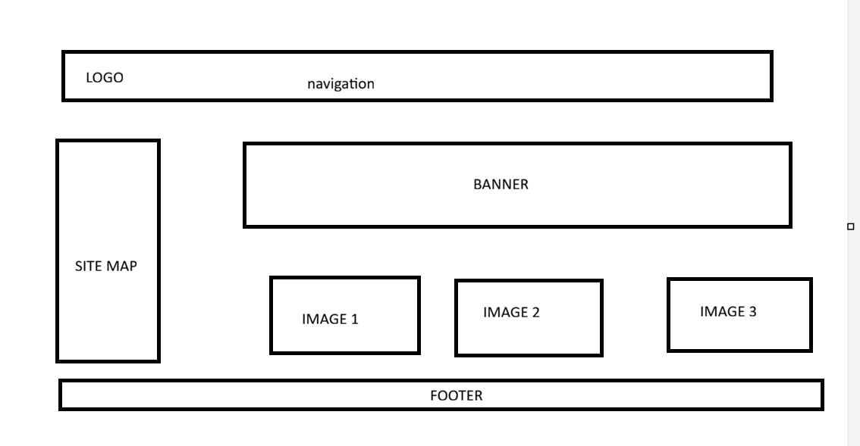
LOW FIDELITY wireframe Homepage
6. Technical Requirements
Domain name:
www.brightfuturetutoring.co.za
Hosting:
Shared web hosting
Programming languages:
HTML, JAVA, CSS
Development tools:
Visual studio code, Github

7. Timeline and Milestones
Week-1 | Gather business requirements and conduct research | Requirements approved
Week-2 | Create website sitemap and wireframes | Design approved
Week-3 | Develop the home, about, and services page | Core pages completed
Week-4 | Develop the registration and contact page | Website functionality completed
Week-5 | Test the website on different devices and browsers | Testing completed
Week-6 | Fix errors, make improvements and prepare documentation | Final website ready for submission

8. Budget
Website design and development | 6,500
Web hosting | 250
Domain name | 1200
Images and graphics | 500
Website testing | 600
Maintenance | 2000
Total budget | 11,050

Proposal 2

Organisation name:
Fresh choice grocery store
Project overview:
Fresh choice grocery store is a local retail business that sells groceries, household products, fresh fruit and vegetables and daily essentials. The business currently relies mainly on walk-in customers and would benefit from a website that showcases products, promotions and store information while allowing customers to browse products online.

- Objectives:
The website will:
Promote the grocery store and its products
Display weekly specials and promotions
Provide store information and operating hours
allow customers to browse products by category
increase customer engagement and attract new shoppers

Target audience
- Residents
- families
- students
- working professionals
- Website features
- The website will contain:
- a homepage
- about us page
- contact page
- products page
- specials page

Expected benefits
The website will improve the stores visibility, attract more customers, advertise promotions effectivity and provide shoppers with quick access to product information before visiting the store. It will also strengthen the business professional image and improve customer satisfaction

Current website analysis
Fresh choice grocery store currently has no official website and mainly advertise through Facebook and printed flyers. Customers cannot browse products or view promotions online

- Areas of improvement
- Create an online business presence
- Display products and weekly specials
- Improve customer communication
- Promote the business to a wider audience
- Increase customer convenience

Proposed website features and functionality

- The website will include:

- Homepage

- About us Page

- Contact page

- Customer enquiry page

- Products page

- Functionality
- Mobile friendly website
- Product categories
- Weekly promotions
- Contact form
- social media integration

- Design and user experience
- Colour scheme:
- Green (freshness)
- White (cleanliness)
- Orange (special offers)

Typography
headings: Bold
Body text : Aptos

Layout and design
- Modern supermarket layout
- Large product images
- Easy to use navigation
- Attractive promotional banners

- User Experience

- Quick access to products

- responsiveness on all devices

- Clear categories

- Fast page loading

- Easy to find contact details

Low-Fidelity wireframe
HOMEPAGE low fidelity wireframe


- Technical requirements
Domian name:
www.freshchoicegrocery.co.za
Hosting:
Shared web hosting
Programming languages:
HTML, CSS, JavaScript
Development tools:
Visual studio code, Github
Browser compatibility:
Chrome, Edge, Safari
Responsive Design:
Optimised for desktop, tablet and mobile devices

Timeline and Milestones
Week-1 | Meet with the client and gather requirements | Project requirements completed
Week-2 | Design the website layout and navigation | Website design approved
Week-3 | Develop the home products and about page | Main pages completed
Week-4 | Create the specials and contact page | Website content completed
Week-5 | Perform testing and resolve any issues | Testing completed
Week-6 | Final review documentation and website submission | Project completed

Budget
Website design and development | 7000
Domain name | 250
Web hosting | 1200
Product image and graphics | 700
Website testing | 650
Maintenance | 2,200
Total budget | 12000

Reference list
HostAfrica. 2025. We hosting services. https://www.hostafrica.co.za/
Google Domains. 2025. Domain registration. https://domains.google/
MDN Web Docs.2025. Learn web development. https://developer.mozilla.org/

